
My visual story through the Abbey
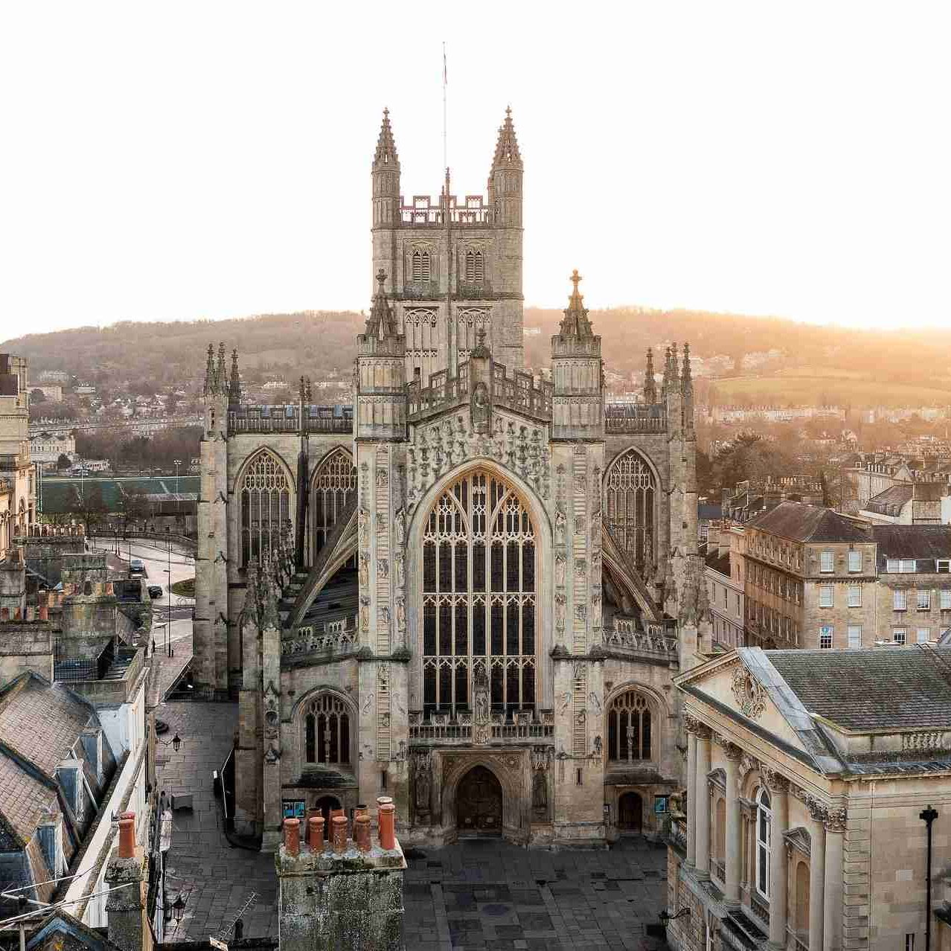

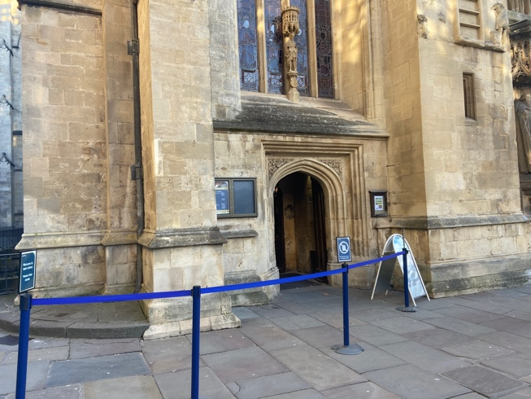
This is where I will queue for the Abbey. If this is too busy, I can ask the staff to let me through another way.

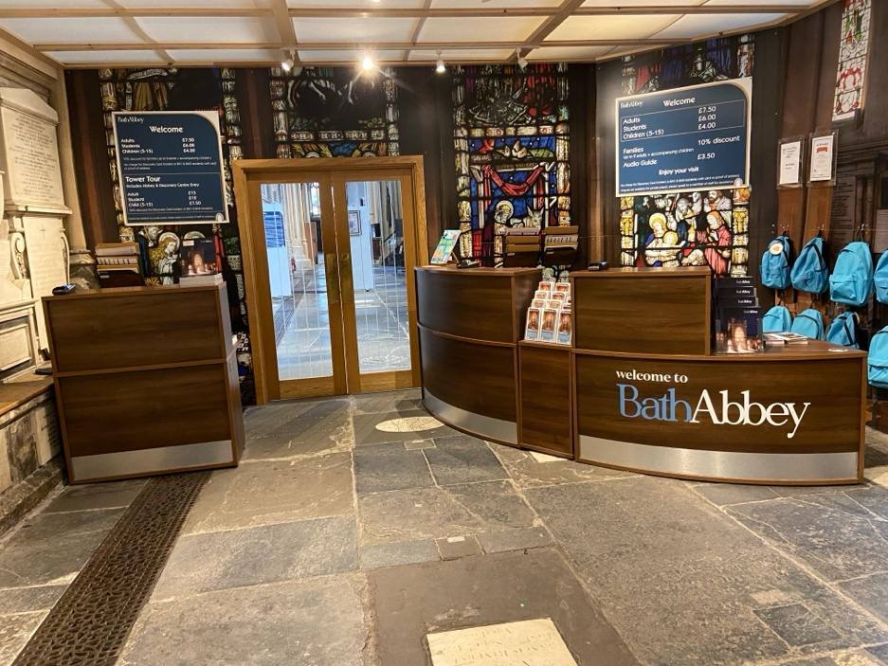

This is where I will get my tickets. I can get an audio guide if I would like one. I can also ask for ear defenders here.
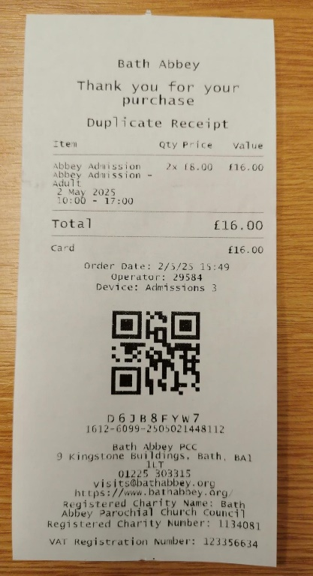

I will keep my ticket in a safe but easy to access place.

If I want, I can take a backpack which has fun items inside to help me explore the Abbey. I will return this at the end of my visit. I can also take a trail sheet.

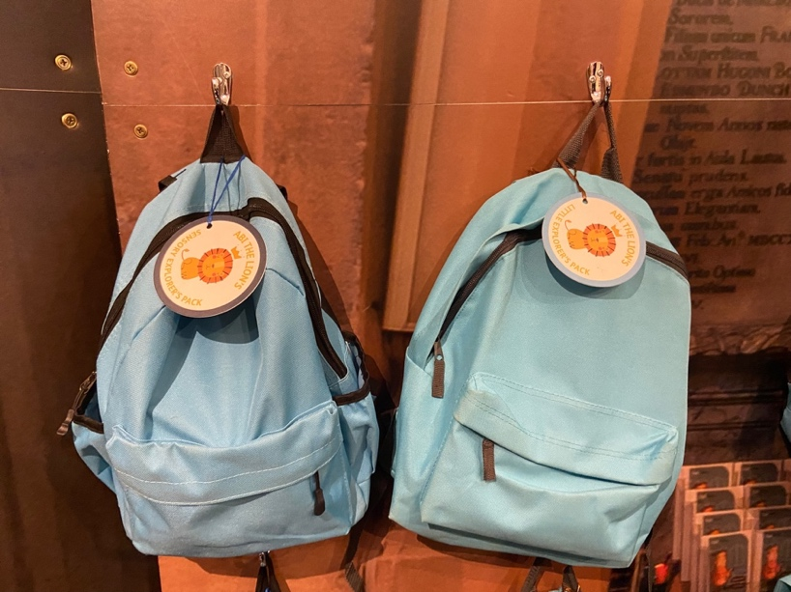

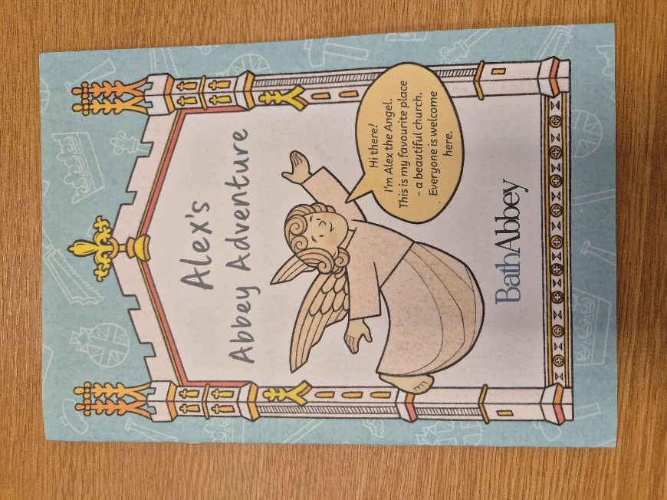
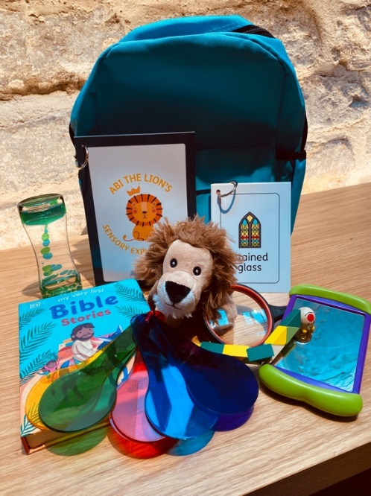
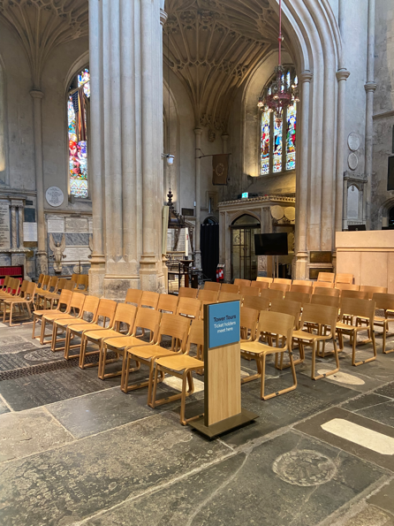
I can also have a tower tour for an extra price if I would like to. If I choose this, I need to be at least 5 years old. I will climb up lots of steep, uneven stairs in a small stairway. I will be in a group of up to 16 people. At the top, I will be able to see a beautiful view of Bath behind barriers. A tour guide will come with me to tell me many stories about the Abbey. The tour will take about 1 hour.
I will meet for the tower tour next to the entrance at this sign.

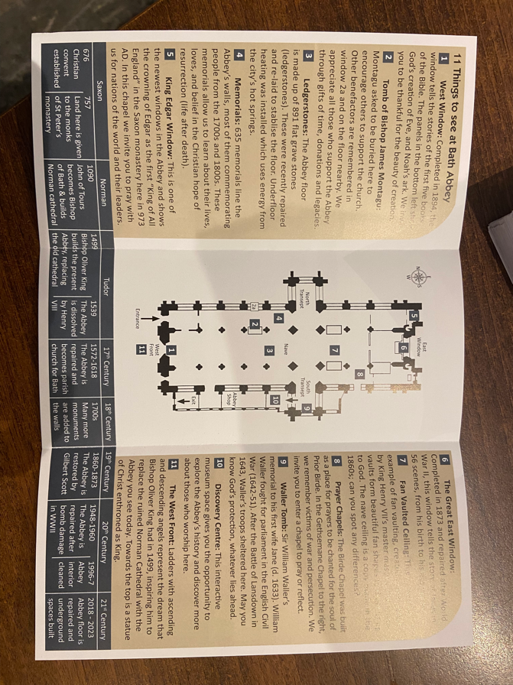
If I want one, I can take an information leaflet. This will help me find interesting places.
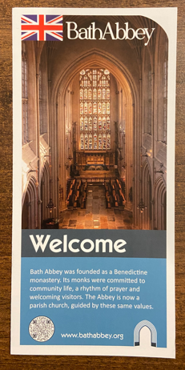

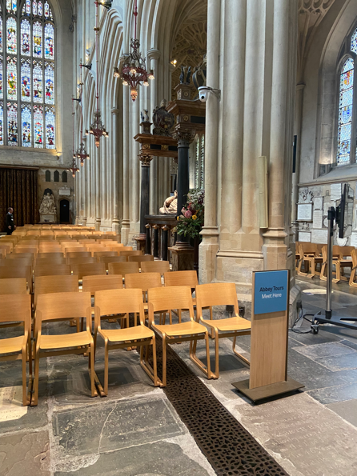
I can have a tour around the Abbey if I would like. The staff will tell me fun facts and show me interesting things.
There is a sign to show where the tour will start.

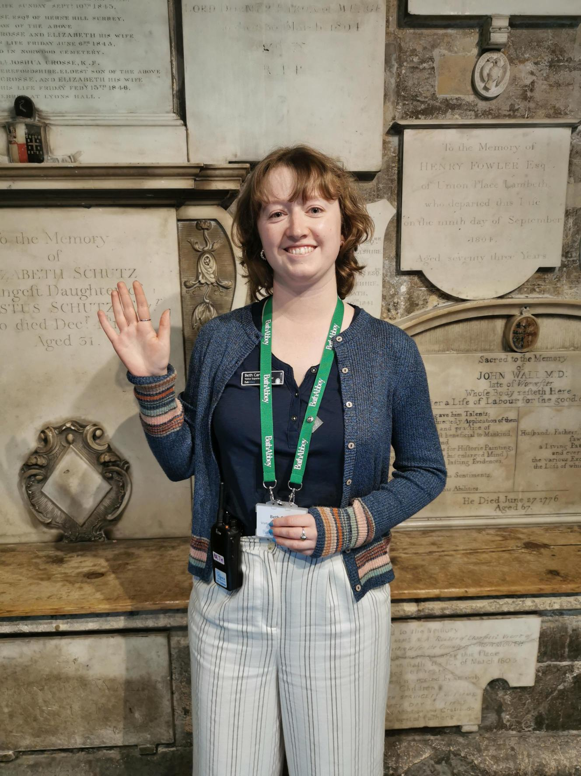
There are blue signs to help me find things. I can also talk to staff with green lanyards on if I need help.

If I hear an alarm, this is where I must go. There are many emergency doors with a fire exit sign.
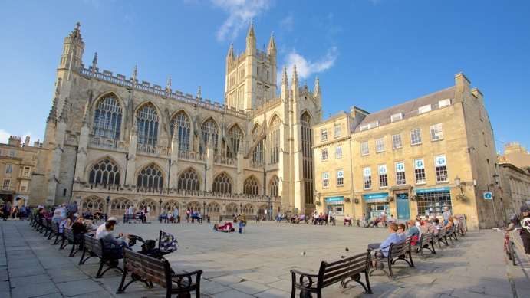
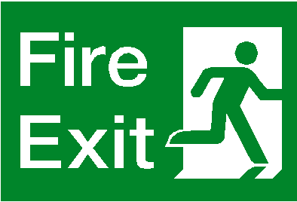

The toilets are through the shop, down the stairs and through the Discovery Centre.
I will turn left ← towards the stairs. I will show my Bath Abbey ticket here to the staff member to get through.
2
I will walk through this archway into the shop.
1

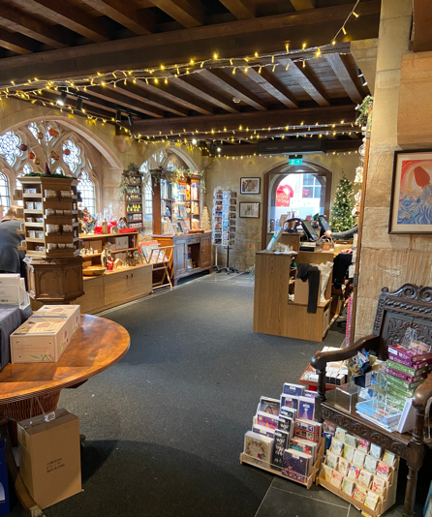
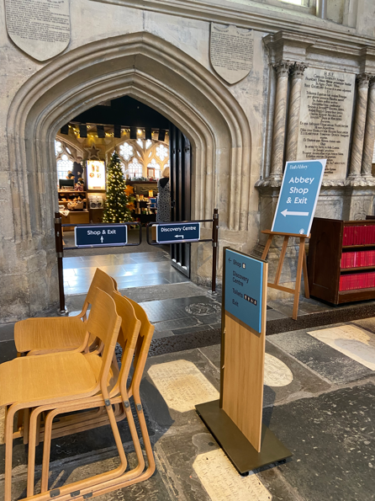
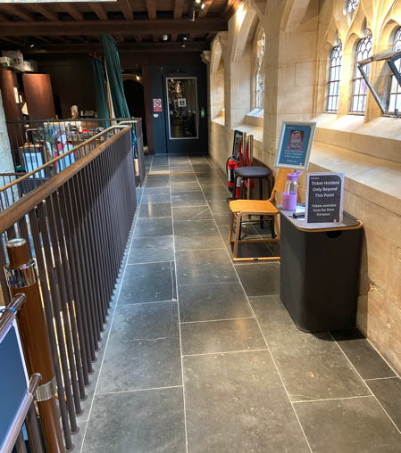

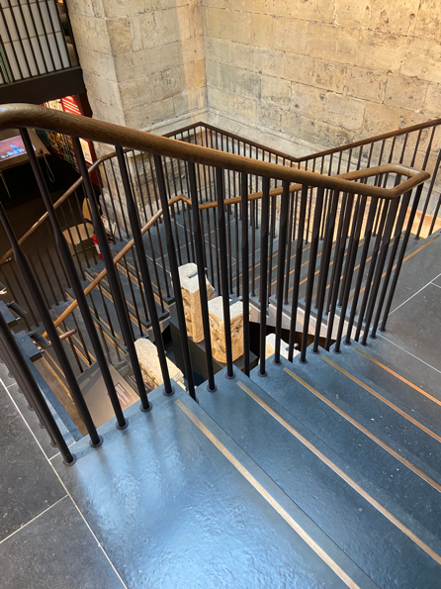
3 I will turn left ← at the bottom of the stairs.

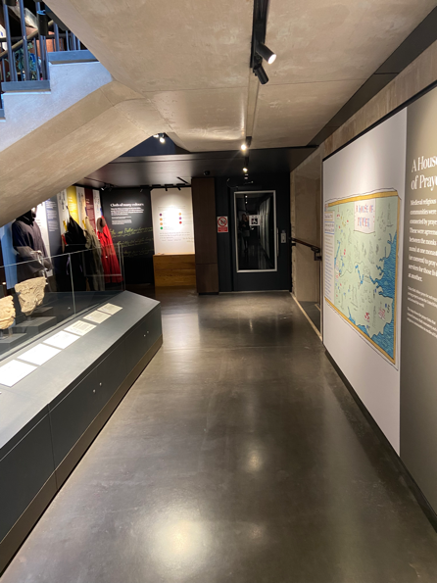
4
I will go down the stairs in the picture on the right →.

5
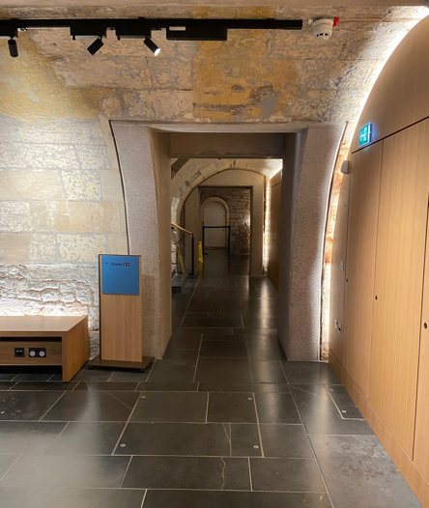
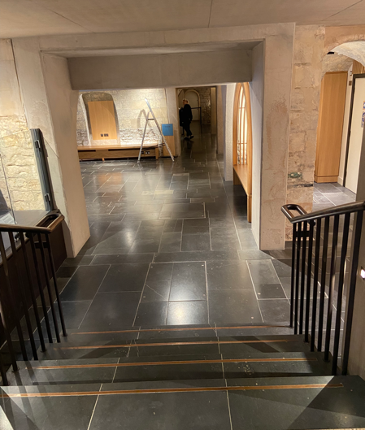
The toilets are straight ahead ↑. The toilets have hand dryers which can be loud.

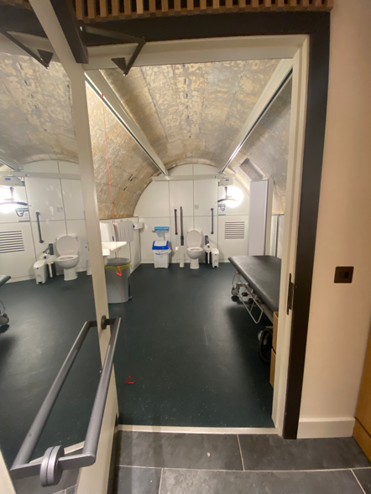
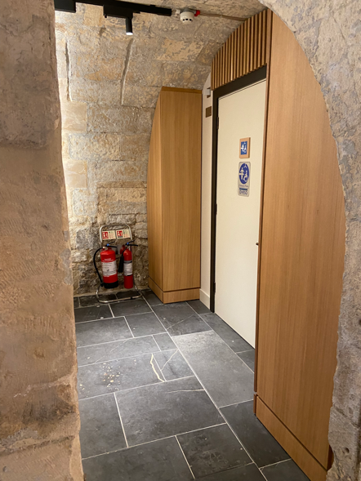
The Changing Places toilet is located to the right → of the toilets. There is also a lift at the end of the corridor in step 2 on the page before.

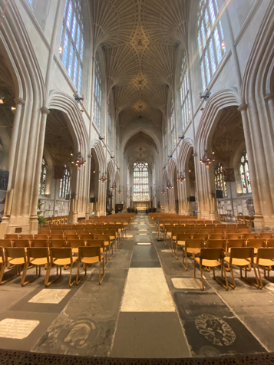
When I get my ticket, I can go into the Abbey. There are many beautiful features to explore.
I can see beautiful stained-glass windows and a unique ceiling.
I can touch the different shaped memorial stones on the walls.
I can smell candles burning, old stone and wood.
I can hear echoing voices of other visitors.
I might be able to hear the music playing. I can use my ear defenders if I do not like this.
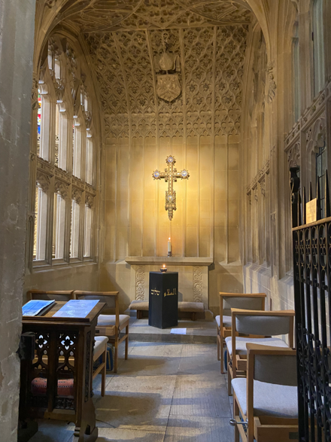
If I get overwhelmed, I can go to number 8 on the map. There are 2 small prayer rooms which are calmer and have lower lighting. There will be less noise and people here.
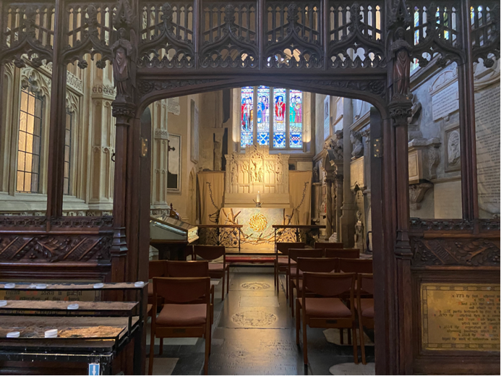

I can find the shop through the barriers in the picture and on the map.
Here I can buy books about the Abbey, stationery, soft toys and much more.

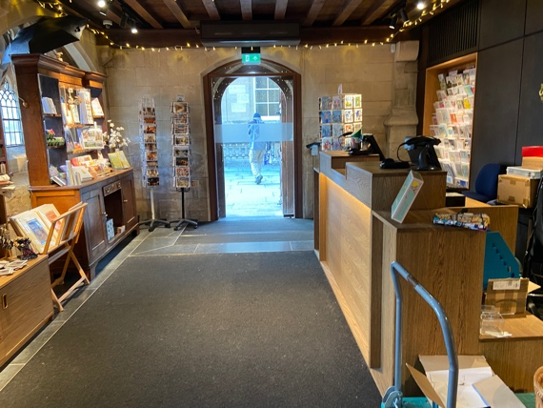
I might notice the lower ceiling and it may feel more crowded. The exit is past the till if I do not feel comfortable.

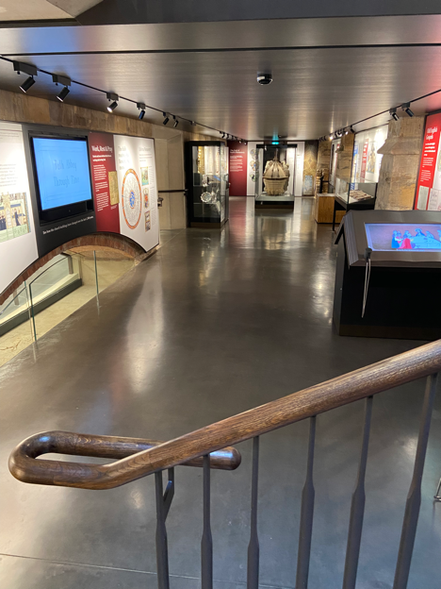
I can walk downstairs to the discovery centre if I would like to. I will show my ticket to the staff member at the top of the stairs.
Here are some interactive games about the Abbey that I can play. There are also objects to look at and costumes to try on.
The discovery centre might feel a little darker and a lower ceiling, but it will not get very crowded because the staff limit the number of people down here.

We really hope you have found this guide helpful. If you have any feedback, please email Polly Andrews, Learning Manager pandrews@bathabbey.org.
For further information please see our website at
https://www.bathabbey.org/accessibility/.

