
Information guide for neurodivergent visitors
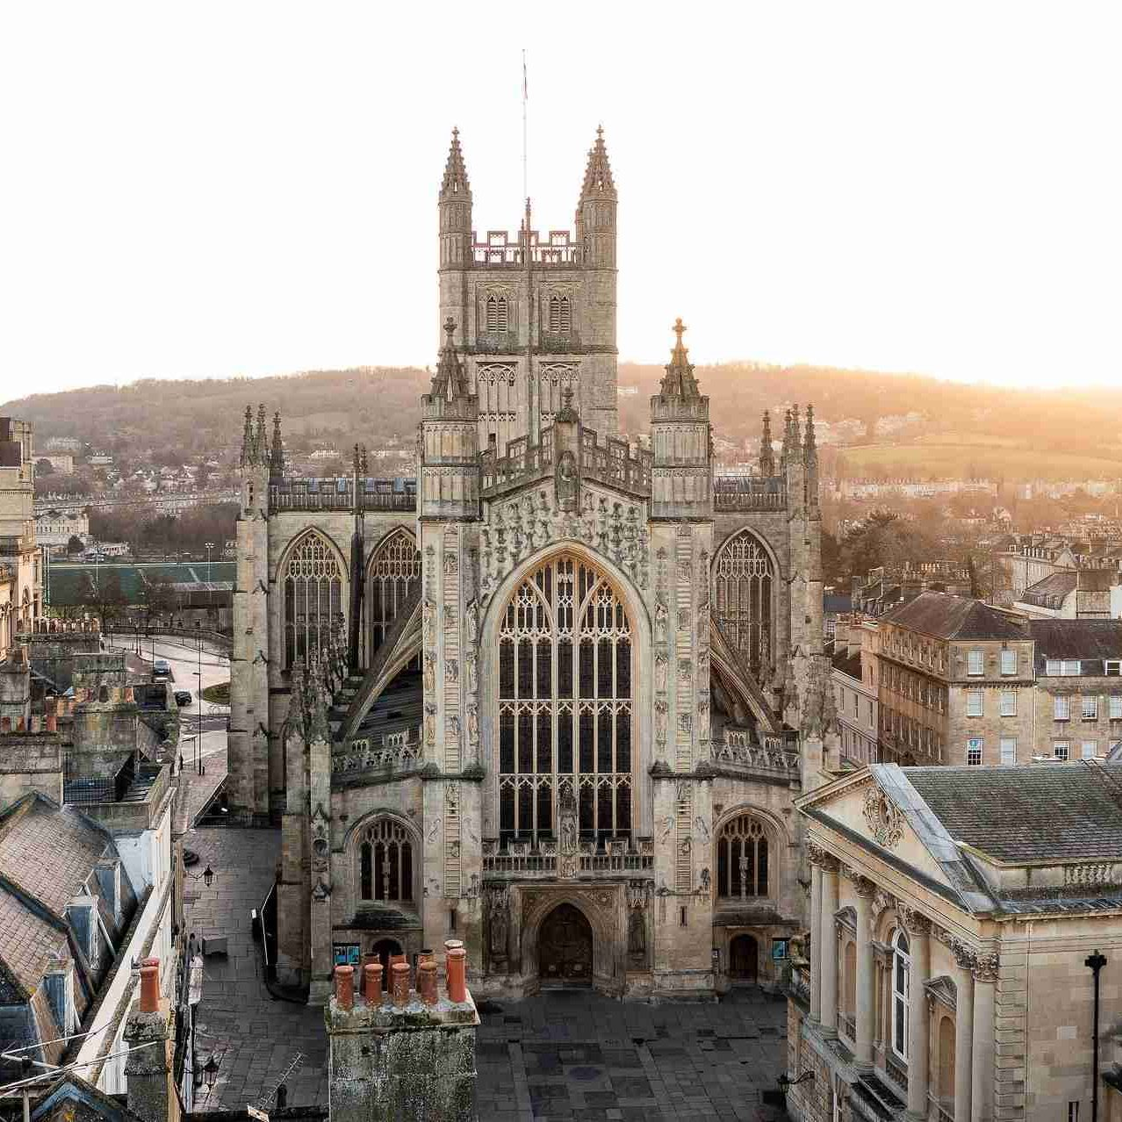
Contents
Page 3
- Entering the Abbey
- Tower tours
Page 4
- Important items you will receive
Page 5
- Abbey tours
- Assistance
- Fire alarms
Page 6
- How to find our toilets
Page 7
- How to find our changing places
- Inside the Abbey
- Calm and less crowded spaces
Page 8
- Things to see
Page 9
- Shop
- Exit
- Discovery centre
Page 10
- Discovery Museum

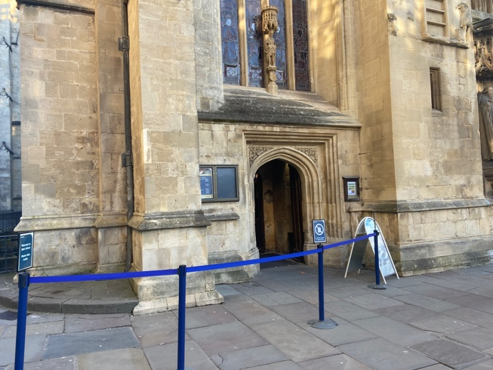
Entering the Abbey
The main entrance is at the front of the Abbey, where you queue to enter. If you find queueing difficult, please speak to our staff. They can show you through a quieter entrance.

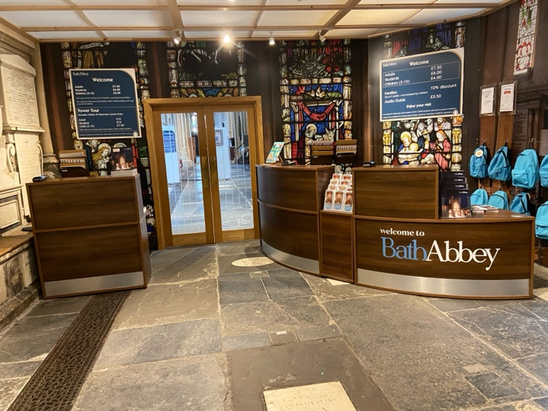
Once you are inside, you can buy a ticket from the front desk staff. If you are local to Bath you can enter for free. You will need to show a Discovery Card or a bill with your address on it.
The prices are located on the wall in the entrance and on the website. It costs £8 for adults, £6.50 for students and £4 for children age 5 – 15. Accompanying carers or support workers can enter for free. You can pay by cash or card. We also provide audio guides which you can play on your phone.
We also provide noise cancelling ear defenders here. Please ask for some if you wish.
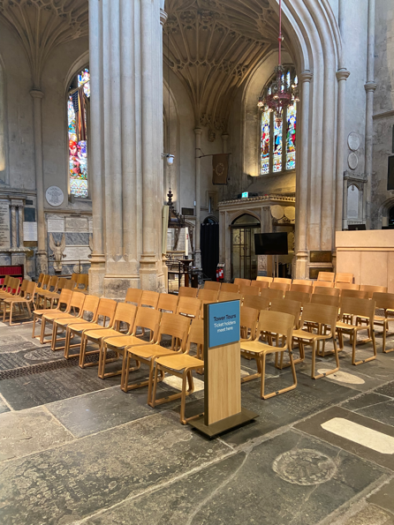
Tower tours
We also provide tower tours for an extra price. This involves climbing up 212 steep, uneven stairs in an enclosed stairway up to the top of the Abbey, where you can see a beautiful view of the city behind high barriers. You will be taken up with a tour guide, who will tell you facts about the Abbey. You will be in a group of up to 16 people. The tour will last approximately 1 hour. If you are interested, please ask for a Tower Tour ticket.
At the desk, our staff will ask you to read through the terms and conditions. If you would like to go ahead, you must sign the consent sheet on your requested time slot. More information can be found on our website at https://www.bathabbey.org/visiting/tours/.
←This is where you should meet for the tower tour. Staff will point you to the sign. This is at the back of the Abbey next to the entrance (near number 1 on the map, which is explained below).
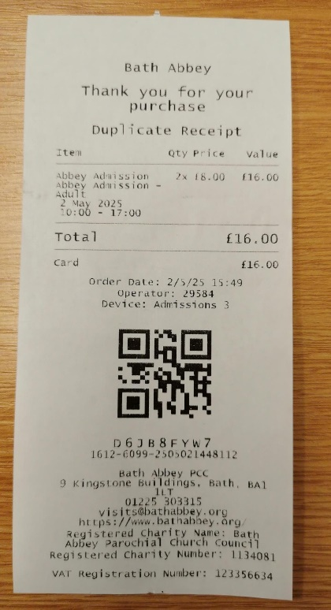
Important items you will receive
Once you have paid, you will be given a ticket. This is valid for the whole day, so you can leave the Abbey and return the same day during opening hours if you wish. Please keep this in a safe place as you will need it to enter the discovery museum.
Please check our website for opening and closing times on the day.

When you arrive, you will also be given an information leaflet which explains some key features of the Abbey. There is a map which shows you important and interesting places.

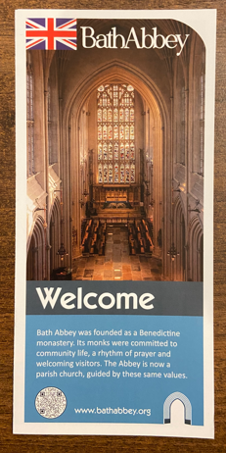
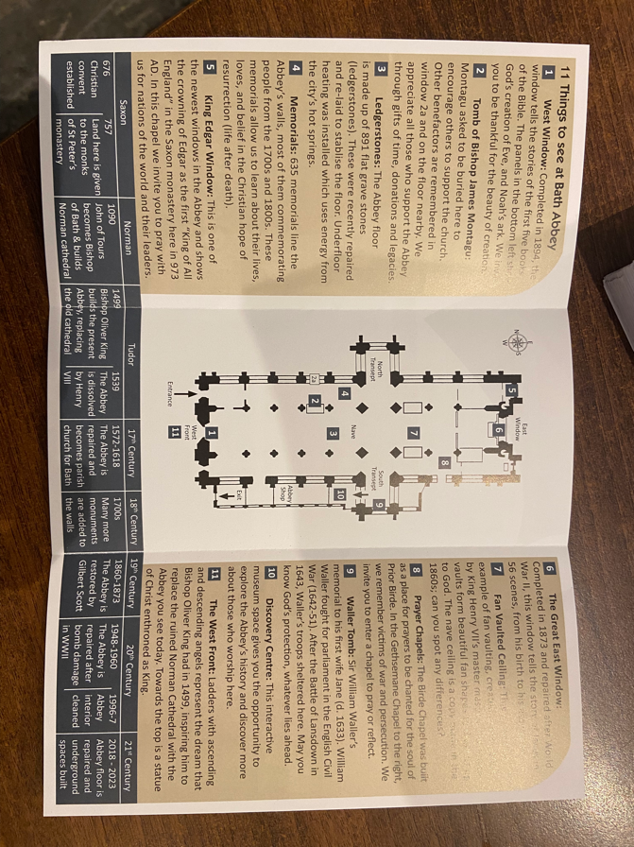

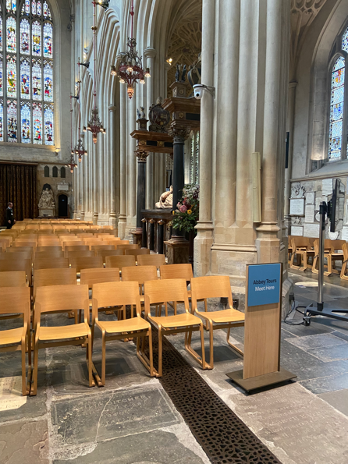
Abbey Tours
Your ticket includes the option to join a free historical tour around the Abbey. One of our staff members will take you to significant places around the Abbey and provide you with interesting facts. These start at quarter past the hour. The number of tours offered vary each day. Please ask staff what tours will be running that day when you arrive.
The meeting point for Abbey tours is next to number 2 on the map.

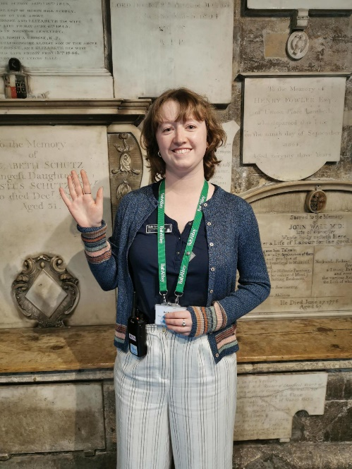
Assistance
There are signs around the Abbey to help you find your way around. There are blue signs for toilets and for the Abbey and Tower Tours.
If you have any questions during your visit, there are staff and volunteers around the Abbey to help you. They wear a green lanyard with their names on. They are there to help to you.
If you require a wheelchair, please call us in advance if possible on 01225 303315 or ask when you arrive.

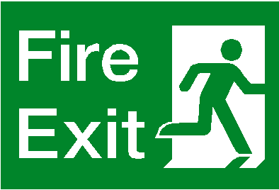
Fire alarms
In the unlikely event that an alarm sounds, please follow staff instructions to find the nearest exit. There are 4 fire exits in the Abbey. They have a green sign above the door.
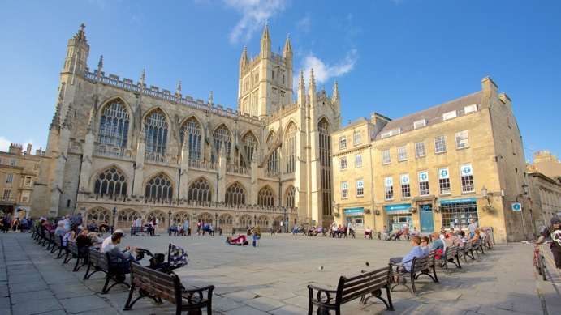
The fire assembly point is the square of benches next to the Abbey.

Toilets
The toilets are located through the shop, down the stairs and through the Discovery Centre.
Walk through this archway on the Abbey floor into the shop.
Turn left ← towards the stairs. A member of staff will be here to check your ticket. Make sure you get this ready.
1
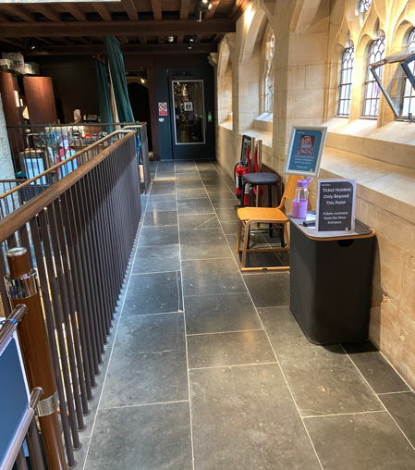
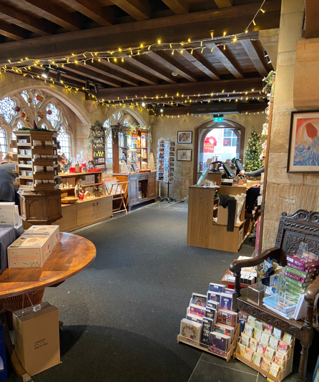
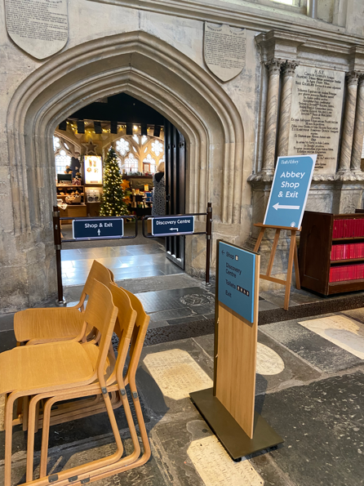
2

Walk down the stairs and turn left ← at the bottom.
3

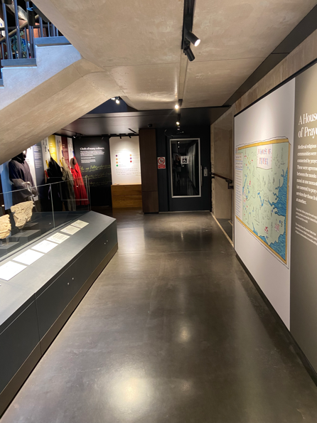
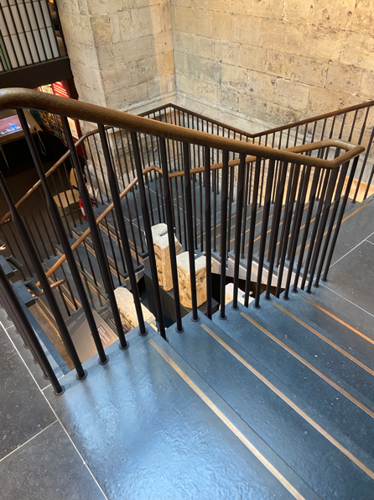
4
Walk down this corridor to the stairs on the right →.

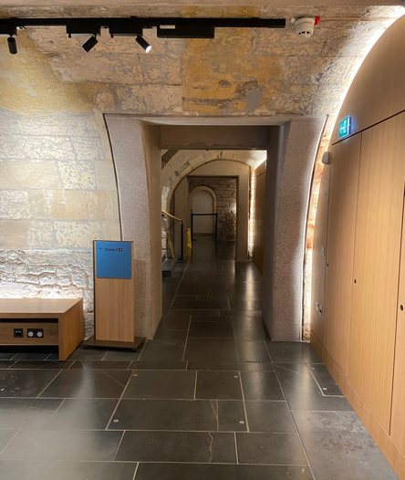
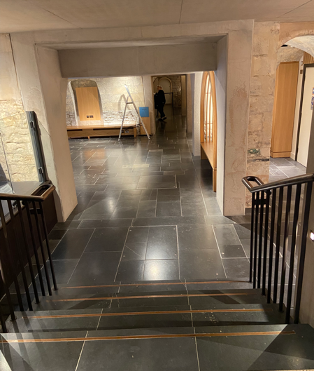
5
The toilets are straight ahead ↑. The toilets have hand dryers which can be loud.

Changing Places
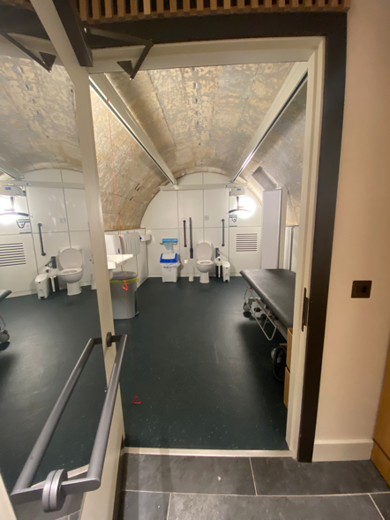
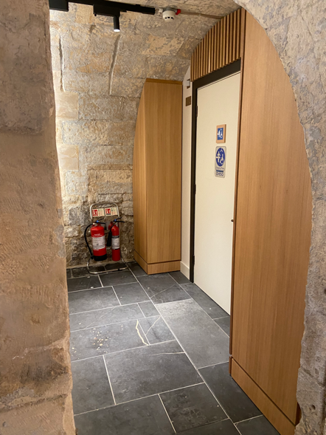
The Changing Places toilet is located to the right → of the toilets. If you require a lift, it is located at the end of the corridor in step 2 (see previous page).

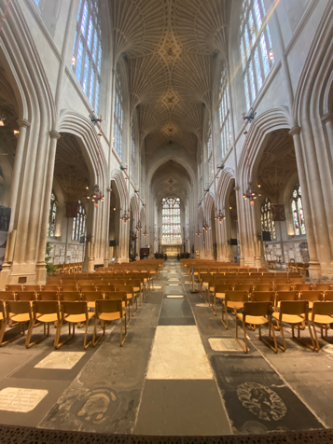
The Abbey
When you get your tickets, you can go through the door to the Abbey. There are many beautiful features inside.
The Abbey can be noisy and busy. However, in the mornings, the Abbey is usually quieter and less busy. If you find it overwhelming at any time, you can go to number 8 on the map. There are 2 small chapels which are enclosed and have lower lighting. There will be less noise and people here.
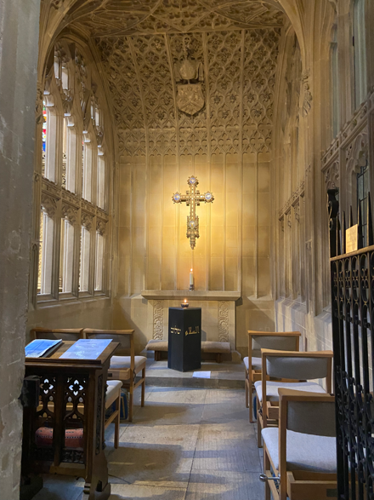

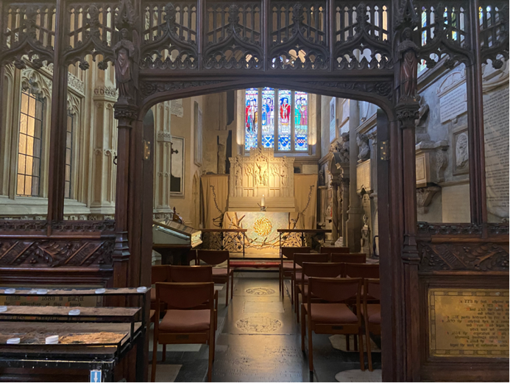

You may also be able to hear music playing in the background. This is only on some days. If it gets too noisy for you, you can borrow ear defenders from the welcome desk.
Prayers are read out loud at 5 minutes past every hour. They last around 2 to 3 minutes. You are welcome to stop and listen if you wish.

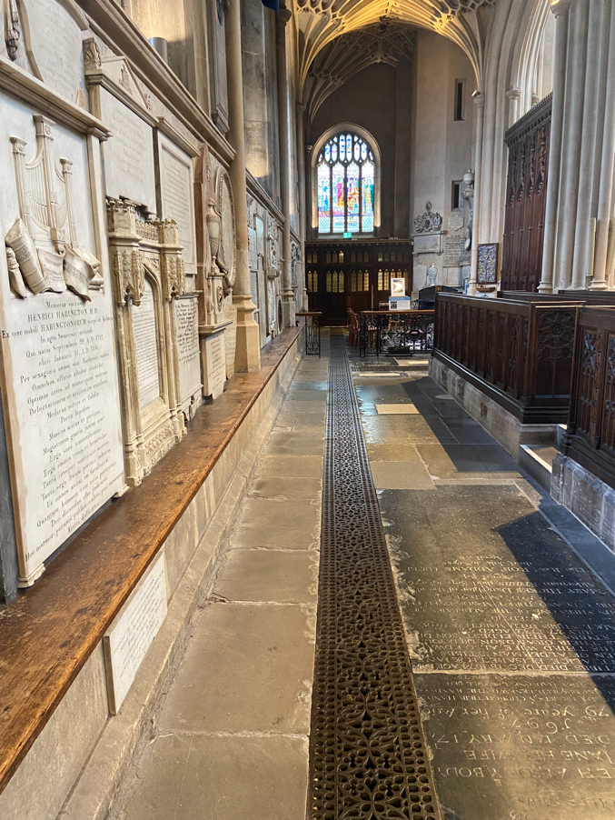
Things to see
There are hundreds of stones on the floor and walls. These are memorials and gravestones of important people to the Abbey and some people were buried here. Feel free to touch these. Some significant memorials are Bishop Montagu (2 on the map) and the Waller Tomb (9 on the map).

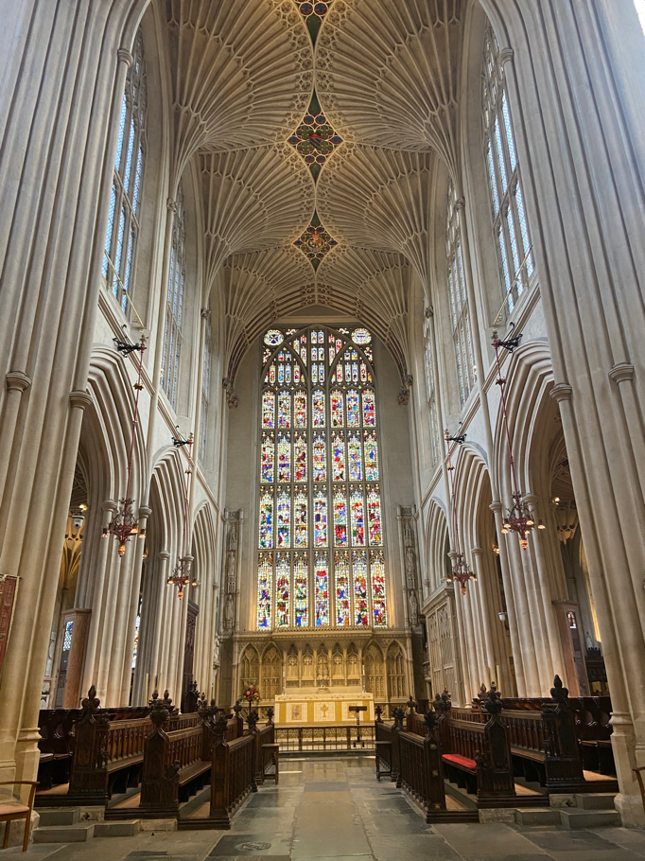
There are many beautiful things to focus on in the Abbey. For example, the fan vaulted ceiling from the 1500s.
On the walls of the Abbey are many windows, some of which have beautiful stained-glass designs. The windows fill the Abbey with natural sunlight. The lighting in the Abbey can vary from very bright in the summer and daytime to dark in the winter and evening.

Shop
You can get to the shop through the barriers. You can also find the shop on the map.
Here you can buy many items related to the Abbey.
Through here, you might notice that the ceiling is lower, and it may feel more crowded. If you find the shop overwhelming, the exit is in the picture below past the tills.

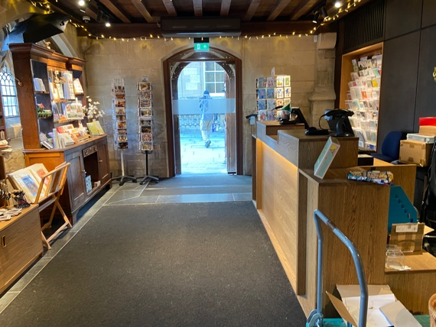
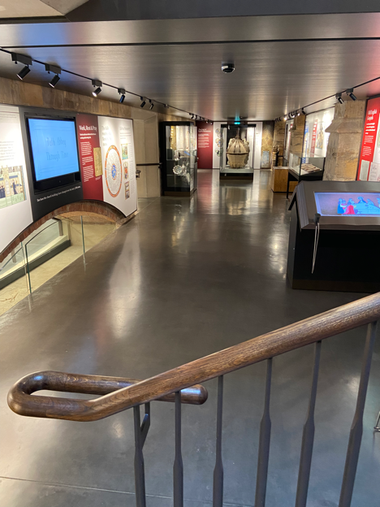
Discovery Museum
The discovery museum is where you can find out more about the history of the Abbey. You will need show your ticket to a staff member at the top of the stairs.
There are interactive games you can play and videos explaining important periods of the Abbey’s history. There are also objects that you can look at and costumes you can try on.
When you come down the stairs, you may notice the darker lighting. You are also underground so there is a slightly lower ceiling. Most of the time, the discovery centre should not get too crowded as we limit the amount of people there. It is quieter in the mornings.
The exit is back up the stairs and through the shop.

We really hope you have found this guide helpful. If you have any feedback, please email Polly Andrews, Learning Manager at pandrews@bathabbey.org.

For further information please see our website at
https://www.bathabbey.org/accessibility/.

